# **Diko’s Farm Grill and Restaurant Reservation Management System**

# **with Data Analytics**

________________________

A Thesis Presented to the Faculty of Computer Science

ACLC College of Santa Maria Bulacan

________________________

In Partial Fulfillment of the Requirements for the

Degree of Bachelor of Science in Computer Science

________________________

**Submitted by:**Marian Rhea Rose O. Bañega

Anjuar Enobio

Jhon Mark L. Villanueva

________________________

**Submitted to:**

Mr. Rohmer Roi A. Bujawe

# **APPROVAL SHEET**

In partial fulfillment of the requirements for the degree of Bachelor of Science in Computer Science, this thesis entitled **"DIKO’S FARM GRILL AND RESTAURANT RESERVATION SYSTEM WITH DATA ANALYTICS"** has been prepared and submitted by **MARIAN RHEA ROSE O. BAÑEGA, ANJUAR ENOBIO** and **JHON MARK L. VILLANUEVA** who is hereby recommended for oral examination.

**MR. ROHMER ROI A. BUJAWE**

Thesis Professor

Examined and approved by the Panel of Examiners in an Oral Examination with a grade of____________on_____________.

**MR. ROHMER ROI A. BUJAWE**

IT Professor

|  |  |
| --- | --- |
| **MR. KURTDALE PALADAN** | **MR. MACRINO BALANGUE** |
| IT Specialist | IT Specialist |

Accepted in partial fulfillment of the requirements for the degree of Bachelor of Science in Computer Science

**MRS. RIZZA A. BALANGUE**

School Director

# **CERTIFICATE OF ORIGINALITY**

I hereby confirm that this thesis is our original work and has a proper citation, to the best of my knowledge and belief, it does not contain any writings or publications that have been previously written or published by other people or organizations, nor any materials that have been approved for the award of any other degree or diploma from a university or other higher education institution, except where due acknowledgment is made thereof.

Additionally, I take full responsibility for the intellectual content, ideas, and arguments presented in this work. This thesis represents our independent research, analysis, and conclusions.

Marian Rhea Rose O.Bañega

Jhon Mark Villanueva

Anjuar Enobio

Canditates

June, 2025

Attested by:

**Mr. Rohmer Roi A. Bujawe**

**Adviser**

August 3,2024

# **GRAMMARIAN'S CERTIFICATE**

This is to certify that the undersigned has viewed and went through all the pages of the

thesis entitled

**“Diko’s Farm Grill and Restaurant Reservation Management System with Data Analytics”**

developed by

**Marian Rhea Rose O. Bañega, Anjuar Enobio,** and **Jhon Mark L. Villanueva**

alighned with the set of structural rules that govern the composition of sentences, phrases, and words in the English language.

**Signed by:**

Ma. Luisa De Guzman Reyes

Grammarian

# **ACKNOWLEDGEMENT**

First and foremost, we would like to express our sincere gratitude to the restaurant manager Mrs. Josephine Agustin, and the staff of **Diko’s Farm Grill and Restaurant** for their cooperation, and willingness to participate in this study. Their insights and feedback played a crucial role in the development of this reservation system with data analytics.

The developers would also like to extend their deepest appreciation to **Mrs. Rizza A. Balangue**, our school director, for her immense knowledge, guidance, and encouragement throughout the entire research process. Her expertise and unwavering support greatly contributed to the successful completion of this study.

Special thanks are also extended to **Mr. Rohmer Roi A. Bujawe**, our thesis professor and mentor, who provided valuable suggestions and guidance during the system's development. His continuous support and motivation have been instrumental in shaping their academic journey over the past four years.

The developers are also thankful to the **faculty and administration of ACLC College of Sta. Maria** for fostering a supportive and enriching learning environment. Additionally, they sincerely thank the entire **AMA Education System** for ensuring the continuity of quality education despite the challenges posed by the pandemic.

The group is also deeply grateful to **classmates**, who have been their companions through all the challenges and struggles of their academic journey, and with whom we have shared countless memories over the years. Furthermore, they would like to recognize and appreciate each other (**Bañega, Enobio,** and **Villanueva**) for their dedication, teamwork, and commitment to completing this study.

Lastly, our heartfelt gratitude goes to our **families** for their unwavering love, patience, and support throughout our educational journey.

Above all, we express our deepest gratitude to **Almighty God** for granting us strength, wisdom, and motivation to accomplish this study without your guidance, none of this would have been possible.

# **DEDICATION**

# **ABSTRACT**

The use of an Online Reservation System to monitor and manage reservations, customer inquiries, and services provided by Diko’s Farm Grill and Restaurant, while also offering an online platform for customers to view available tables and promotions, is essential for achieving an efficient business process and providing excellent service.

The purpose of this study is to identify the challenges faced by Diko’s Farm Grill and Restaurant in managing reservations and develop a solution.

Reservation Management System with Data Analytics is designed to streamline the booking process, optimize table management, and provide valuable business insights through data analytics. To assess the effectiveness and acceptability of the developed system, the team surveyed restaurant staff and customers.

Reservation Management System with Data Analytics is highly effective and can serve as a significant improvement over the restaurant’s existing reservation process.

# **TABLE OF CONTENT**

**Preliminaries**  Page

Title Page i

Approval Sheet ii

Certificate of Originality iii

Grammarian's Certificate iv

Acknowledgement v

Dedication vii

Abstract viii

Table of Contents ix

List of Tables xii

List of Figures xiii

**CHAPTER**

I. THE PROBLEM AND ITS SETTING

Introduction 14

Conceptual Framework 16

Statement of the Problem 18

Assumption of the study 19

Scope and Limitation of the Study 19

Significance of the Study 20

Definition of Terms 21

Page

II. REVIEW OF RELATED LITERATURE AND STUDIES

Related Literature 26

Related Studies 28

III. RESEARCH METHODOLOGY

Method of Research 31

Description of Respondents 38

Data Analysis 39

Research Instrument 40

Data-Gathering Procedure 40

Statistical Treatment of Data 41

IV. PRESENTATION, ANALYSIS AND INTERPRETATION OF DATA

Functionality. 43

Reliability. 45

Usability. 46

Efficiency 48

Maintainability 49

Portability 51

Summary 52

Page

V. SUMMARY, CONCLUSIONS, AND RECOMMENDATIONS

Summary of Findings 54

Conclusions 56

Recommendations 57

APPENDICES

**A.** SOFTWARE EVALUATION FORM 59

**B.** QUESTIONNAIRE FORM 61

**E.** Reference: 62

CURRICULUM VITAE 64

# 

# **LIST OF TABLES**

Page

Table 3.1 42

Table 4.1 43

Table 4.2 45

Table 4.3 46

Table 4.4 48

Table 4.5 49

Table 4.6 51

Table 4.7 52

# **LIST OF FIGURES**

Page

Figure 1 16

Figure 2 33

Figure 3.1 34

Figure 3.2 35

Figure 3.3 36

Figure 4 38

**Chapter I**

# **THE PROBLEM AND ITS SETTING**

### **Introduction**

The restaurant industry prospers by delivering customer satisfaction through convenience, efficiency, and personalization. Traditional reservation methods tend to fail to meet customers' demands, leading to human errors, miscommunication, piling-up workloads, and inefficiencies during peak hours.

Diko’s Farm Grill and Restaurant Reservation Management System with Data Analytics focuses on these kinds of struggles which we integrated with data-driven solutions. The system streamlines the reservation process with features such as proof of reservation and table information with visuals. It is incorporated with the GCash transaction feature, allowing customers to confirm their reservations through online payments. This feature will ensure trust between the restaurant and the customer while reducing customer booking cancellations.

The system enforces a time limit for reservations to optimize table turnover, providing efficiency during the busiest hours. By developing the reservation system, this project aims to be a large help for “Diko’s Farm Grill and Restaurant,” reducing the restaurant's workload and enhancing customer satisfaction. **Theoretical Framework**

*Unified Theory of Acceptance and Use of Technology 2* (Venkatesh, V.,et al., 2012)

Thong, J. Y. L., & Xu, X. (2012), UTAUT2 expands on the original UTAUT framework by focusing on consumer adoption of technology. It introduces additional constructs such as Hedonic Motivation, Price Value, and Habit, making it particularly relevant for systems that target end-users.

*Application to the System:*

The proposed reservation management system uses UTAUT2 to identify key factors affecting customer uptake including perceived ease of use, perceived enjoyment, and price perception to improve usage.

*Data-Driven Decision Making (DDDM) (Provost and Fawcett 2013)*

Popularized in the 21st century by researchers like Provost and Fawcett (2013), DDDM emphasizes the use of data analytics to drive better business decisions. The inclusion of data analytics in the proposed system allows the restaurant to identify trends, manage peak times effectively, and improve overall customer service based on data insights.

By integrating these theories, the project ensures a robust theoretical foundation for addressing the inefficiencies of manual reservation systems and delivering a high-quality automated solution.

### **C:\Users\ACER\Desktop\Research Folder\I P O.pngConceptual Framework**

**Figure 1.** Paradigm of the Study

**Input:**

These are the resources and technologies that drive the system, such as Reservation Booking, Online transactions, and Receipt Reference. These elements serve as the foundation for the system's design and implementation.

**Process:**

This represents the steps involved in developing and executing the system, including:

1. Validating reservations using Receipts
2. Processing payments through online
3. Organizing data analytics to provide operational insights.

**Output:**

The desired outcome is improved operational efficiency and customer satisfaction. The system is designed to offer a seamless reservation process and eliminate errors caused by manual handling.

### **Statement of the Problem**

The current manual reservation system employed by "Diko's Farm Grill and Restaurant" presents several challenges which include the following:

1. **Inefficiency and Errors:** Staff manually handle the reservation; this tends to get mistaken, such as incorrect bookings which result to customers being displeased.
2. **Lack of Secure Validation:** Without proof of transactions, the restaurant loses the trust of both sides and customers.
3. **Limited Customer Information:** Customers always want to seek more details/information, such as descriptions and visuals before they proceed to reservation.
4. **Communication Bottlenecks:** The manager handles all the reservation and contacts all by herself which cause piling workload, delayed responses, and dissatisfaction with the customer experience.
5. **Sub-optimal Table Utilization:** Not implying a time limit for reservations tends to lead to inefficiency, such as seating turnover, which happens during peak hours.

The proposed system resolves these issues by making efficient reservation system and payment processes, integrating Reference ID validation, and offering secure GCash transactions, enhancing both customer trust and operational efficiency.

### **Assumption of the study**

This study operates under the following assumptions:

1. Employees and managers of Diko’s Farm Grill and Restaurant are open to change and will take time to learn how to properly navigate the new reservation management system.
2. Customers will easily understand the publicly available interface and adapt to it for making reservations and payments.
3. It would be designed with enough reliability and security features to protect the customers’ data and transactions against minor problems.
4. The Internet connection at the restaurant is good and sufficient for online-related features such as GCash and all reservation confirmations.
5. The data collected by the proposed system will be accurate and complete to deliver pertinent information for decision-making and operations enhancement.

### **Scope and Limitation of the Study**

The study aims to implement a reservation management system fitted for Diko’s Farm Grill and Restaurant. The system includes adaptable table management, providing security with Reference ID validation, and is also included with GCash transactions for online payment and reservation confirmation.

Our scope encompasses the connection between manual and computerized systems, establishing an efficient reservation process. Our system applies strictly inside the restaurant’s operations, accessible to the manager for securing and monitoring data. While the system focuses on adapting to table turnovers, it also enhances the customer experience. The system limitations are not implemented with third-party services and functional or stable internet connectivity for accessing reservations and transactions.

### **Significance of the Study**

By conducting this research, the study aims to generate valuable insights that will be useful not only to the researcher but also to the following groups of individuals:

**Restaurant Conductors:** This will be an insight to improve decision-making and services by making efficient reservations and table management which decrease errors and workloads.

**Future Conductors:** Providing our system will help upcoming conductors to learn efficient reservation, data analytics, and understand the restaurant operations.

**Students:** Let the students gain useful knowledge of the development of the system and data analytics which shows that technology makes better business operations and decision-making.

**Customers:** Customers always seek to be pleased such as being provided with a faster and personalized reservation process implemented in the system.

**Restaurant Growth:** The system enhances efficiency, and customer service, and gives insights that increase profitability.

### **Definition of Terms**

To facilitate the understanding of this study, different terms are defined herein;

**Automated Booking:** The use of technology to allow customers to reserve tables without manual input from restaurant staff.

**Bottleneck:** Any specific tasks or stages within your production line that slow down the entire production process, causing delays, missed deadlines, and financial losses for the facility.

**Business Insights:** Actionable knowledge derived from data analytics that helps managers make strategic decisions.

**Conductors:** People who conduct; a leader, guide, director, manager, staff, or researchers.

**CSS (Cascading Style Sheets):** A style sheet language which is used to define the presentation and layout of a web page that enhances its visual appearance.

**Customer Retention:** The ability of a restaurant to keep customers return by offering reliable service and enhancing their overall experience.

**Customer Satisfaction:** The degree to which a restaurant meets or exceeds customer expectations improved by streamlined booking processes and personalized service.

**Data Analytics:** The process of examining datasets to draw conclusions and make informed decisions. In this study, it helps restaurant managers analyze customer trends, peak hours, and operational performance.

**Dining Experience Personalization:** Customizing the dining experience to suit individual preferences such as choosing specific tables or time slots.

**Error:** The state or condition of being wrong in conduct or judgment.

**HTML (HyperText Markup Language):** The standard language used to structure and display content on web pages, forming the backbone of most websites.

**Internet Connectivity:** The reliance on a stable internet connection for the system to function effectively, particularly for online reservations and data syncing.

**JS (JavaScript):** A programming language that enables interactive elements on web pages, such as animations, form validations, and dynamic content updates.

**Manual Reservation System:** The traditional approach to handling bookings, often involving pen-and-paper methods or basic digital tools, is prone to errors and inefficiencies.

**Node.js:** A runtime environment that allows JavaScript to be executed on the server side, enabling scalable and efficient back-end development.

**Operational Efficiency:** The ability of the restaurant to maximize productivity with minimal wasted effort, time, or resources, enhanced by the system's automation and data features.

**PHPMailer:** A PHP library used to send emails securely and efficiently through web applications, supporting advanced email features like attachments and HTML formatting.

**PHP (Hypertext Preprocessor):** A server-side scripting language designed for web development, used to create dynamic and interactive web pages.

**Reference ID Validation:** A feature that generates unique identifiers for reservations, ensuring the security and authenticity of bookings.

**Reservation Management System:** A software system developed to handle the booking process for tables inside the restaurant. It includes scheduling, data analytics, and table information.

**Scalability:** The ability of a system to handle increased workload or expand its capacity without compromising performance.

**Software System:** A collection of programs, configuration files, documentation, and other components that work together as part of a computer system.

**Sub-optimal:** Less than the highest standard or quality.

**System Scalability:** The system's capability to grow in capacity or functionality as the restaurant's needs expand, is crucial for adapting to higher customer demand or new services.

**Table Turnover:** The rate at which tables in a restaurant are occupied and vacated, indicating how efficiently seating capacity is utilized.

**User Interface (UI):** The visual and interactive components of the system that allow users to interact with its features, such as booking and table selection.

**Utilization:** The action of making practical and effective use of something.

With the help of these definitions, one can have a basic understanding of the terms used in this research study.

**Chapter II**

# **REVIEW OF RELATED LITERATURE AND STUDIES**

This chapter presents a systematic organization of literature and studies, which are relevant to the topic at hand. It includes both foreign and local sources to showcase the importance of the current research. The researchers have carefully selected and included relevant literature and studies to demonstrate the significance of their investigation. Furthermore, to enhance understanding and grasp the key points of the study, a summary of the literature is also provided.

### **Related Literature**

*Monitoring Work and Automating Task Allocation in Retail and Hospitality (Christl, W., 2023)*

This research examines the role of automation in enhancing task allocation and monitoring within the hospitality sector. Christl's study emphasizes how automated systems, such as reservation and table management systems, are increasingly used to streamline operations in restaurants and hotels. These systems aim to boost efficiency, reduce human error, and improve service delivery by optimizing task distribution across various roles. The study concludes that automation significantly improves operational efficiency by enhancing productivity and minimizing common challenges like overbooking and staffing inefficiencies. Moreover, implementing automated systems helps businesses maintain a competitive edge by improving customer satisfaction and service quality. The research highlights the ongoing need to integrate new technologies to meet industry demands and evolving customer expectations.

*Full-Service Restaurant Management Information System Selection Model (Kurzina, I., 2017)*

This study explores the selection and integration of management information systems in full-service restaurants. Kurzina’s research focuses on how analytics and automation contribute to better decision-making and optimized operations in the hospitality sector. It highlights the role of management information systems in improving various aspects of restaurant management, such as inventory control, customer service, and staffing efficiency. The research concludes that the right management information system can significantly improve the operational processes of full-service restaurants. It finds that automated systems enhance decision-making and operational efficiency while boosting customer satisfaction. Additionally, the study stresses that choosing the appropriate system depends on the specific needs and goals of the restaurant, ensuring that the technology aligns with operational demands.

*Disruptive Technologies and Innovation in Hospitality: A Computer-Assisted Qualitative Data Analysis Approach (Lee, M., Sisson, A. D., & Costa, R., 2023)*

This research investigated the role of disruptive technologies in hospitality, particularly focusing on automated systems for improving customer experiences. Lee, Sisson, and Costa's study delves into how technologies like AI and automated reservation systems are transforming the hospitality industry. It used qualitative data analysis to understand how these technologies affect both customer satisfaction and operational efficiency. The study concluded that disruptive technologies, especially automation and AI, offer substantial benefits for hospitality businesses by improving efficiency and customer engagement. The researchers argued that these innovations allowed for better personalization of services and operational processes. Moreover, the research emphasized the need for hospitality businesses to continuously innovate and embrace these technologies to stay competitive in a rapidly changing market.

### **Related Studies**

*A Proposed Reservation Client Ordering with Sales and Production Monitoring System at SG Farm (Abenoja, J. P., Dela Cruz, C. B., & Resurreccion, M. C., 2018)*

This study focused on developing a computerized reservation and ordering system tailored for SG Farm, a poultry business. The researchers designed a system that automated the manual processes of handling reservations and orders, utilizing a centralized database to track customer orders, reservations, and sales. The system also incorporated restricted access for managers and owners to ensure the security of business data. The system improved the accuracy and reliability of order and reservation management, reducing errors caused by manual record-keeping. The automation streamlined operations, allowing for real-time updates and better management of customer orders. Moreover, it enhanced service delivery and operational efficiency, addressing challenges such as inefficiencies and incorrect record-keeping. The study concluded that the proposed reservation and ordering system significantly improved business operations at SG Farm. By automating manual processes, the system increased accuracy, reduced errors, and enhanced customer satisfaction. The research emphasized the importance of transitioning from manual to digital processes for improved business efficiency and service quality.

*Artificial Intelligence for Hospitality Big Data Analytics: Developing a Prediction Model of Restaurant Review Helpfulness for Customer Decision-Making (Lee, M., Kwon, W., & Back, K. J., 2021)*

This study examined the application of artificial intelligence in analyzing big data, such as customer reviews, to improve decision-making and service quality in the hospitality sector. The researchers developed an AI-based prediction model to evaluate the helpfulness of restaurant reviews based on customer feedback and behavior. They utilized big data analytics to analyze patterns and predict which reviews were most influential in customer decision-making. The AI model successfully predicted the helpfulness of restaurant reviews, providing valuable insights into customer behavior and preferences. The study showed that reviews with higher helpfulness ratings were more likely to influence potential customers' decisions. The results highlighted the importance of customer-generated content in shaping restaurant choices and improving service quality. The study concluded that AI-driven analytics could enhance decision-making in the hospitality sector by accurately predicting the helpfulness of customer reviews. This predictive approach aids in refining service offerings and improving overall customer satisfaction. The research underscored the role of big data analytics in transforming customer experiences in hospitality.

*Analytics Applications, Limitations, and Opportunities in Restaurant Supply Chains (Swink, M., Hu, K., & Zhao, X., 2022)*

The researchers analyzed various analytics applications used in restaurant supply chains, focusing on automation and its impact on decision-making processes. They also discussed the limitations of these technologies in addressing real-world challenges. The study found out that analytics tools improved decision-making in restaurant supply chains, helping optimize inventory management, reduce waste, and improve operational efficiency. However, it also highlighted the limitations of automation, such as the need for accurate data inputs and the potential for technology to overlook complex human factors. The researchers concluded that while analytics and automation have significant potential to optimize restaurant supply chains, there are challenges in their application. They emphasized the importance of balancing automation with human judgment and continuously refining analytics tools to address limitations and enhance decision-making. The study advocates for ongoing advancements in analytics to overcome current challenges and unlock further opportunities in the industry.

**Chapter III**

# **RESEARCH METHODOLOGY**

Chapter 3 focuses on the tools that we use to support our study. It includes the method of research, choosing the respondents, developing and justifying the research instrument, and carrying out data-gathering procedures. With these methodologies, the chapter provides a complete general review of the planned approach to conducting the study.

### **Method of Research**

This study was conducted through a qualitative and quantitative research method to fully understand what is wanted inside the reservation management system. Qualitative gathering allows us to research the very depth of the system and how it will impact restaurant operations while aiming for user experiences and operational efficiency. We fully immersed ourselves.

* + - 1. Visually Observing – We observe how the staff and customer interacted in a real-time scenario
      2. Asking Scenario-based Surveys – We will survey the staff and administrator with different problems and how would they give them solutions that will be applied to our system.

Quantitative gathering will provide us with a noticeable ratio from our respondents to focus on the more impactful desire for the system. Gathering numbers based on which they put more focus. Expected respondents are:

IT Professors – We want them to give us insights, and provide us information that can improve our system.

IT Experts – With their extensive experience in software development and system design, we seek their professional insights to enhance the functionality, security, and efficiency of our system.

Admin/Staff/Customers – Civils will provide us with both quality and quantity information on how they interact within the system

These included expanding our knowledge by studying analytics, transactions, and both traditional and computerized processes of reservation systems. This method will help us understand both the traditional and computerized processes of the restaurant that will be applied inside the system.

To develop our reservation management system, we used the Waterfall Model System Development Life Cycle. The waterfall model is a breakdown of developmental activities into linear, sequential phases. It was integrated into small projects such as our reservation system at Diko’s Farm Grill and Restaurant. We want the system to be completely justified by each step, making our system well-structured and reducing its risk of failing before it is released to the users. We chose the waterfall model since we intend only to be used by “Diko’s Farm Grill and Restaurant” and not to include third parties while being efficient with cost and time.

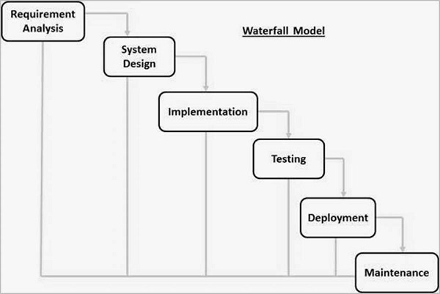

**Figure 2.** Waterfall Model

The system was developed using the Waterfall Model System Development Life Cycle, ensuring a structured, sequential approach that minimizes risks and focuses on cost and time efficiency for Diko’s Farm Grill and Restaurant.

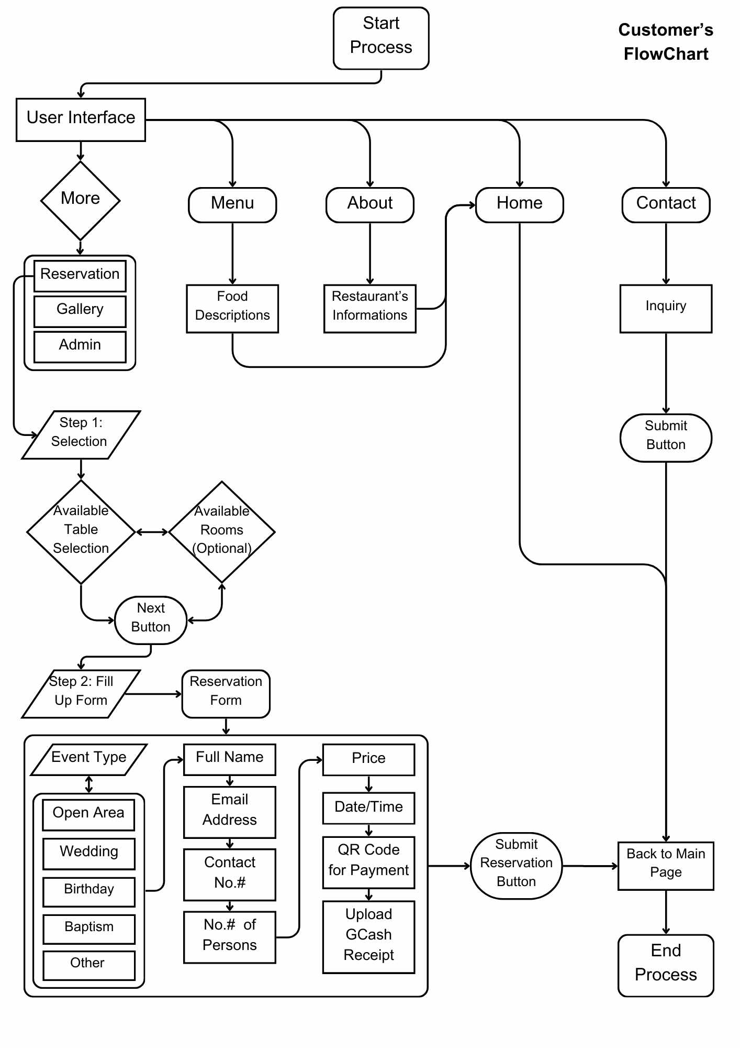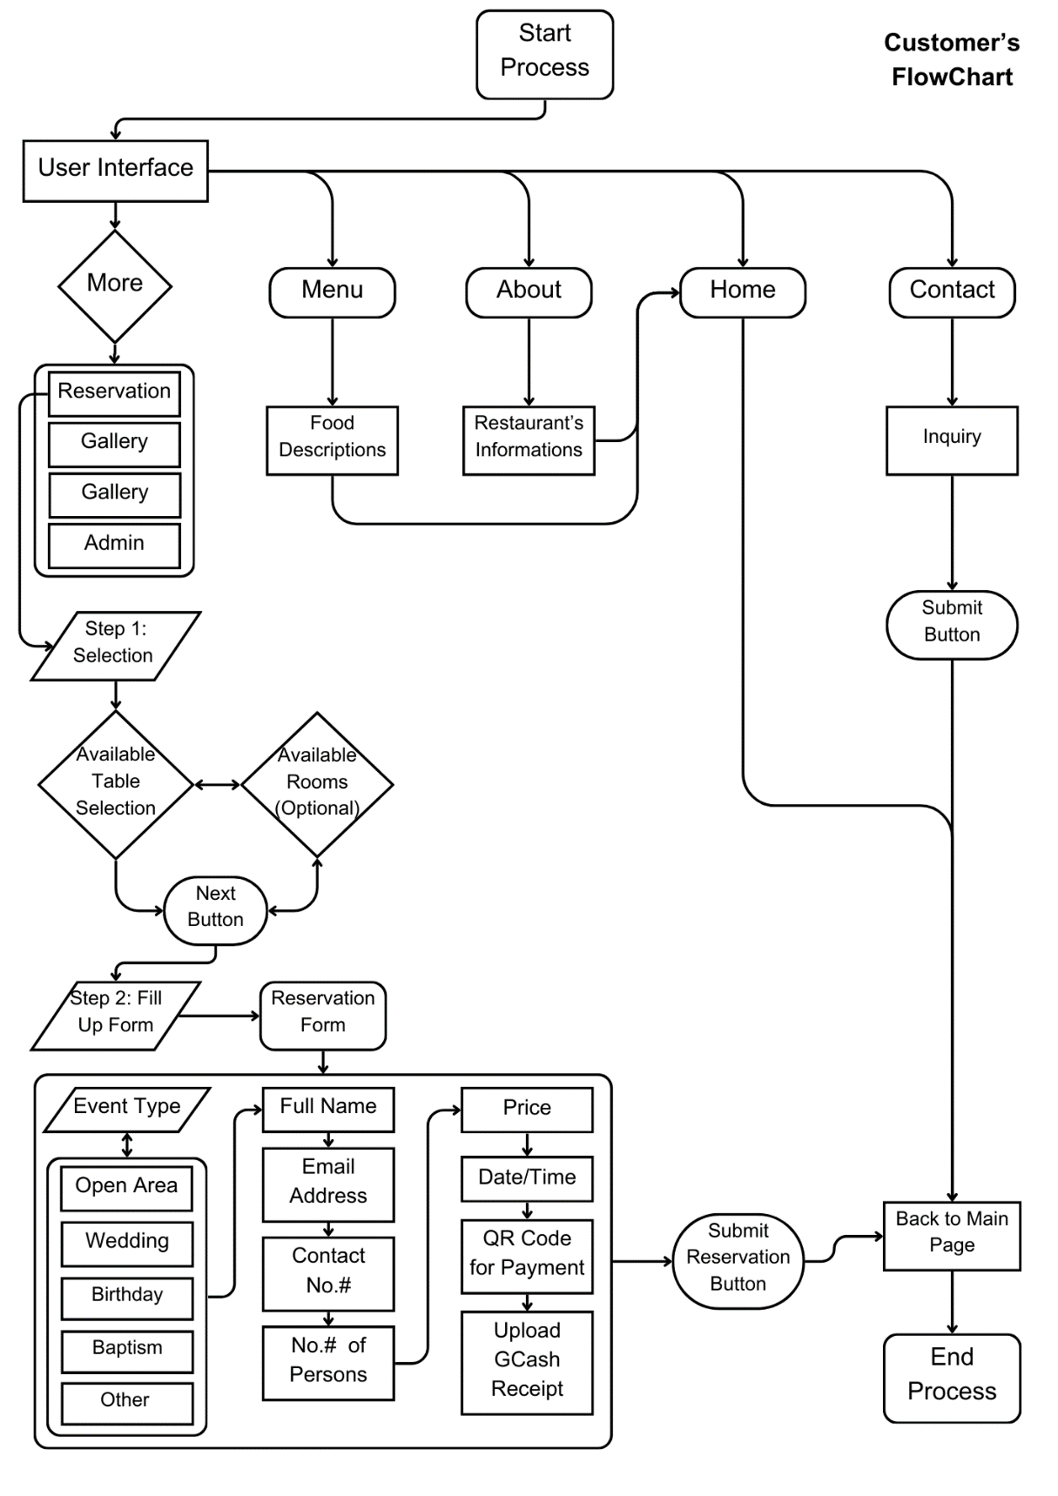**Flowchart of the Study**

**Figure 3.1** Flowchart for Customers

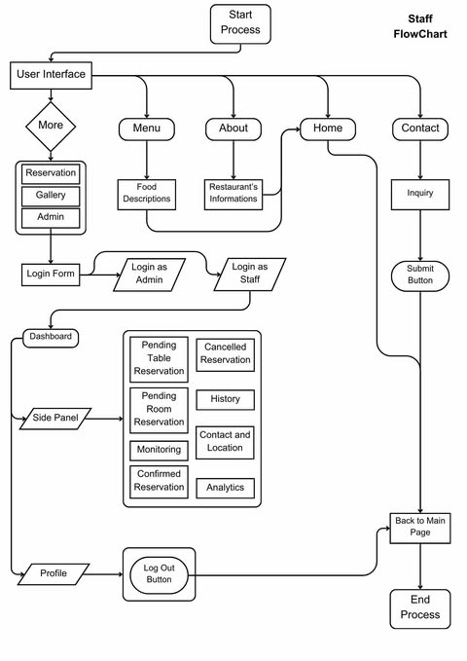 **Figure 3.2** Flowchart for Staff

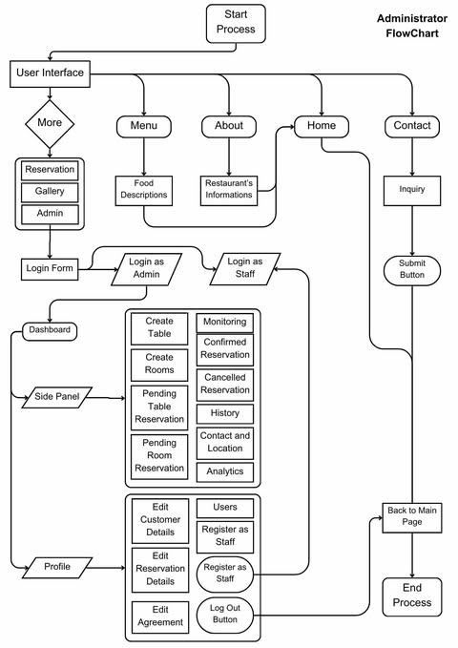

**Figure 3.2** Flowchart for Administrator

We developed two flow charts that show both customers and admin/staff would progress inside the reservation management system. Customers can access the website for every panel shown, including what they can input in the reservation panel, but this excludes the admin panel. The admin panel is exclusively accessible to the admin and staff only. The admin panel contains the data of every transaction, analytics, and history which can be manipulated by the admin/staff.

**Use-Case Diagram of the Study**

The diagram illustrates the interactions between three users (customers, admin, and staff) and the Reservation Management System, highlighting key functions such as reservations, menu, admin login, online transactions, and data analytics.

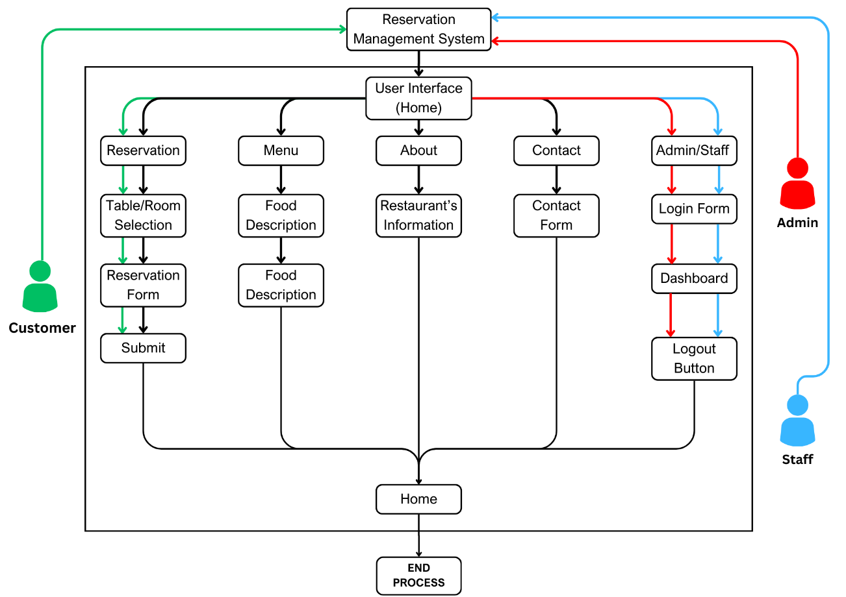

**Figure 4.** Use-Case Diagram of the Study

### **Description of Respondents**

The respondents for this study were carefully selected to ensure that their insights and expertise align with the research objectives. Their roles and experiences are pivotal in providing qualitative data that will inform the design and evaluation of the proposed reservation management system.

**Mr. Bernard Molina** is responsible for processing reservations and payments while ensuring the accuracy of customer bookings. He verifies reservations using Reference IDs, handles and secures online transactions, and update the system with walk-in customer details. His role supports efficient table management and minimize errors in the reservation process.

**Ms. Josephine Agustin,** a restaurant manager with hands-on experience in managing reservation systems, provided an operational perspective. Her input focused on usability, staff workload, and customer satisfaction, ensuring that the system meets the practical needs of restaurant operations.

These respondents, with their diverse yet complementary expertise, were instruments in shaping the development of the system, ensuring that it is both effective and user-friendly.

### **Data Analysis**

The thematic analysis technique was used to interpret the qualitative data developed from interviews, observations, and scenario-based surveys. Identifying, analyzing, and interpreting patterns or themes were developed to uncover insights regarding the reservation system being proposed. It commenced with familiarization: going through the data in-depth and thoroughly to understand the scope involved. Initial codes that reflect recurring ideas were derived; these were then further aggregated to form themes that represent primary findings.

### **Research Instrument**

The research instruments were conducted with semi-structured interviews, visual observation, and scenario-based surveys. Our respondents provided us with knowledge about system design and data analytics through interviews and revisions. Inspection of the system emphasized the effects of table turnover, restaurant efficiency, and customer satisfaction. Scenario-based surveys cover the actual problems and the process inside and outside the restaurant, making our respondents provided feedback that would make our system effectively usable and efficient for the user.

### **Data-Gathering Procedure**

Data collection started with interviews with our specialists in system design and analytics, aiming for expertise in developing systems. We, researchers and the respondents applied our knowledge to develop solutions for the restaurant. These interviews were conducted with observational sessions within the restaurant environment, writing down interactions between staff, customers, and the traditional process. We also provided scenario-based surveys given to the restaurant owners and how they adapt to these operational issues. The gathered data were organized and applied to the system.

### **Statistical Treatment of Data**

To implement the Design and Implementation of Diko’s Farm Grill and Restaurant Reservation Management System with Data Analytics, the proponent used some instruments to improve the quality of the software. The following Software Quality Factors were used as follows:

**Functionality** is a set of attributes that bear on the capability to provide functions that meet stated and implied needs when the software is used.

**Reliability** is a set of attributes that bear on the capability to maintain a specified level of performance.

**Usability** is a set of attributes that bear on the capability to be understood, learned, and used.

**Efficiency** is a set of attributes that bear on the capability to provide appropriate performance relative to the number of resources used.

**Maintainability** is a set of attributes that bear on the capability to modify for 56 purposes of making corrections, improvements, or adaptations.

**Portability** is a set of attributes that bear on the capability to be adapted for different specified environments without applying actions or means other than those provided for this purpose in the product.

The system was evaluated against functionality, reliability, usability, efficiency, maintainability, and portability. The developed system’s acceptability was measured using the Likert Scale and the ranking was as follows: Highly Acceptable if the computed average was 4.5 to 5, Very Acceptable if the computed average was 3.50 to 4.49, Acceptable if the computed average was 2.50 to 3.49, Moderately Acceptable if the computed average was 1.50 to 2.49, and Unacceptable if the computed average was 1 to 1.49.

|  |  |
| --- | --- |
| **Mean Score** | **Interpretation of Mean** |
| 1.00 – 1.49 | Unacceptable (U) |
| 1.50 – 2.49 | Moderately Acceptable (MA) |
| 2.50 – 3.49 | Acceptable (A) |
| 3.50 – 4.49 | Very Acceptable (VA) |
| 4.50 – 5.00 | Highly Acceptable (HA) |

**Table 3.1** Interpretation of Acceptability

**CHAPTER IV**

# **PRESENTATION, ANALYSIS AND INTERPRETATION OF DATA**

This chapter discusses the assessment of the manual existing system as well as the analysis of the respondents to the developed system. There are tables below showing the acceptability of the developed system in terms of Functionality, Reliability, Usability, Efficiency, Maintainability, and Portability.

**Table 4.1**

### **Assessment of end-user and I.T. experts to the proposed Diko’s Farm Grill and Restaurant Reservation Management System with Analytics in terms of Functionality for Diko’s Farm Grill.**

|  |  |  |  |  |  |  |
| --- | --- | --- | --- | --- | --- | --- |
| Functionality | End-Users | | IT Experts | | Over-All | |
| Avg. | Q.I. | Avg. | Q.I. | Avg. | Q.I. |
| 1. Suitability or the software has suitable but appropriate set of functions in accordance to its system objectives | 4.70 | HA | 4.83 | HA | 4.77 | HA |
| 2. Accuracy or the system can provide an accurate result. | 4.60 | HA | 5.00 | HA | 4.80 | HA |
| 3. Compliance or the system defines the set of needs or information. | 4.50 | HA | 5.00 | HA | 4.75 | HA |
| Over-All | 4.60 | HA | 4.94 | HA | 4.77 | HA |

Legend: 4.50 to 5.00 (Highly Acceptable–HA); 3.50 to 4.49 (Very Acceptable-VA);2.50 to 3.49 (Acceptable-A); 1.50 to 2.49 (Moderately Acceptable-MA); 1 to 1.49 (Unacceptable-U)

Table 1 shows the assessment of end-users and IT experts regarding the proposed Diko’s Farm Grill and Restaurant Reservation Management System with Analytics in terms of Functionality. The data indicates that "Accuracy or the system can provide an accurate result" received the highest average of 4.60 for end-users with a qualitative interpretation of highly acceptable and 5.00 with a qualitative interpretation of highly acceptable for IT experts, leading to a computed overall average of 4.80, which is also interpreted as highly acceptable.

"Compliance or the system defines the set of needs or information" received the lowest average of 4.50 for end-users with a qualitative interpretation of highly acceptable, and 5.00 with a qualitative interpretation of highly acceptable for IT experts, resulting in a computed overall average of 4.75, which is still highly acceptable.

"Suitability or the software has a suitable but appropriate set of functions in accordance with its system objectives" received an average of 4.70 for end-users, with a qualitative interpretation of highly acceptable, and 4.83 with a qualitative interpretation of highly acceptable for IT experts, leading to a computed overall average of 4.77, which is also highly acceptable.

In terms of overall Functionality, the end-users provided an overall average rating of 4.60, while the IT experts gave 4.94, both interpreted as highly acceptable. The overall computed average stands at 4.77, also interpreted as highly acceptable. These findings are supported by Data-Driven Decision Making (DDDM) (Provost and Fawcett, 2013), which emphasizes the use of analytics and measurable data to inform business and system decisions. The inclusion of data analytics in the proposed system allows for accurate assessments, structured compliance, and suitability in accordance with user needs. The high ratings suggest that data-driven insights were utilized to optimize the functionality of the system, ensuring efficiency, precision, and continuous improvement based on real-world feedback.

**Table 4.2**

### **Assessment of end-user and I.T. experts to the proposed Diko’s Farm Grill and Restaurant Reservation Management System with Analytics in terms of Reliability for Diko’s Farm Grill.**

|  |  |  |  |  |  |  |
| --- | --- | --- | --- | --- | --- | --- |
| Reliability | End-Users | | IT Experts | | Over-All | |
| Avg. | Q.I. | Avg. | Q.I. | Avg. | Q.I. |
| 1. Fault tolerance or the system can still perform after power lost. | 4.80 | HA | 4.83 | HA | 4.82 | HA |
| 2. Recoverability on the system can record saved form. | 4.70 | HA | 4.83 | HA | 4.77 | HA |
| Over-All | 4.75 | HA | 4.83 | HA | 4.79 | HA |

Legend: 4.50 to 5.00 (Highly Acceptable–HA); 3.50 to 4.49 (Very Acceptable-VA); 2.50 to 3.49 (Acceptable-A); 1.50 to 2.49 (Moderately Acceptable-MA); 1 to 1.49 (Unacceptable-U)

Table 2 shows the assessment of end-users and IT Experts regarding the Diko’s Farm Grill and Restaurant Reservation Management System with Analytics in terms of Reliability. The table indicates that in terms of Reliability, “Fault tolerance or the system can still perform after power loss” received the highest average of 4.80 with a qualitative interpretation of highly acceptable for end-users and 4.83 with a qualitative interpretation of highly acceptable for IT Experts, resulting in a computed overall average of 4.82 with a qualitative interpretation of highly acceptable.

“Recoverability or the system can record saved form” received a slightly lower average of 4.70 with a qualitative interpretation of highly acceptable for end-users and 4.83 with a qualitative interpretation of highly acceptable for IT Experts, leading to a computed overall average of 4.77 with a qualitative interpretation of highly acceptable.

In terms of overall Reliability, end-users gave an average rating of 4.75 with a qualitative interpretation of highly acceptable, while IT Experts provided an average of 4.83 with a qualitative interpretation of highly acceptable. The overall computed average is 4.79 with a qualitative interpretation of highly acceptable. This study aligns with Data-Driven Decision Making (DDDM) (Provost & Fawcett, 2013), which emphasizes the role of data analytics in making informed business and technological decisions. By leveraging reliability metrics, Diko’s Farm Grill and Restaurant Reservation Management System with Analytics ensures that data insights drive improvements in functionality, providing a robust platform that enhances user trust and system efficiency.

**Table 4.3**

### **Assessment of end-user and I.T. experts to the proposed Diko’s Farm Grill and Restaurant Reservation Management System with Analytics of Usability for Diko’s Farm Grill.**

|  |  |  |  |  |  |  |
| --- | --- | --- | --- | --- | --- | --- |
| Usability | End-Users | | IT Experts | | Over-All | |
| Avg. | Q.I. | Avg. | Q.I. | Avg. | Q.I. |
| 1. Understandability or the system is user friendly. | 4.60 | HA | 4.50 | HA | 4.55 | HA |
| 2. Learn ability or the system is easy to understand. | 4.70 | HA | 4.50 | HA | 4.60 | HA |
| 3. Operability or the system is easy to operate. | 4.60 | HA | 4.83 | HA | 4.72 | HA |
| Over-All | 4.63 | HA | 4.61 | HA | 4.62 | HA |

Legend: 4.50 to 5.00 (Highly Acceptable–HA); 3.50 to 4.49 (Very Acceptable-VA); 2.50 to 3.49 (Acceptable-A); 1.50 to 2.49 (Moderately Acceptable-MA); 1 to 1.49 (Unacceptable-U)

Table 3 shows the assessment of end-users and IT Experts of the proposed Diko’s Farm Grill and Restaurant Reservation Management System with Analytics in terms of Usability. The table indicates that in terms of Usability, “Operability or the system is easy to operate” received the highest average of 4.60 with a qualitative interpretation of Highly Acceptable for end-users and 4.83 with a qualitative interpretation of Highly Acceptable for IT Experts, collecting a computed average of 4.72 with a qualitative interpretation of Highly Acceptable.

“Understandability or the system is user-friendly” acquired an average of 4.60 with a qualitative interpretation of Highly Acceptable for end-users and 4.50 with a qualitative interpretation of Highly Acceptable for IT Experts, collecting a computed average of 4.55 with a qualitative interpretation of Highly Acceptable.

“Learnability or the system is easy to understand” acquired an average of 4.70 with a qualitative interpretation of Highly Acceptable for end-users and 4.5 0with a qualitative interpretation of Highly Acceptable for IT Experts, collecting a computed average of 4.60 with a qualitative interpretation of Highly Acceptable.

In terms of Usability, the end-users acquired an overall average of 4.63 with a qualitative interpretation of Highly Acceptable, while the IT Experts received an overall average of 4.61 with a qualitative interpretation of Highly Acceptable. The overall computed average is 4.62 with a qualitative interpretation of Highly Acceptable. This finding is supported by the Unified Theory of Acceptance and Use of Technology 2 (UTAUT2) by Venkatesh et al. (2012). UTAUT2 expands on the original UTAUT framework by emphasizing consumer adoption of technology, incorporating constructs such as Hedonic Motivation, Price Value, and Habit. These constructs are particularly relevant for systems targeting end-users, such as the proposed Diko’s Farm Grill and Restaurant Reservation Management System with Analytics. As the field of restaurant management continues to evolve, the application of UTAUT2 within the system enables effective adoption by considering key factors such as perceived ease of use, perceived enjoyment, and price perception. These elements contribute to an improved reservation experience, encouraging more users to engage with the system and enhancing operational efficiency. By leveraging these principles, the system effectively aligns with modern technological advancements, ensuring a seamless and user-friendly reservation management experience.

**Table 4.4**

### **Assessment of end-user and I.T. experts to the proposed Diko’s Farm Grill and Restaurant Reservation Management System with Analytics in terms of Efficiency for Diko’s Farm Grill.**

|  |  |  |  |  |  |  |
| --- | --- | --- | --- | --- | --- | --- |
| Efficiency | End-Users | | IT Experts | | Over-All | |
| Avg. | Q.I. | Avg. | Q.I. | Avg. | Q.I. |
| 1. Time behavior or the system has a quick response | 4.30 | VA | 4.66 | HA | 4.48 | VA |
| Over-All | 4.30 | VA | 4.66 | HA | 4.48 | VA |

Legend: 4.50 to 5.00 (Highly Acceptable–HA); 3.50 to 4.49 (Very Acceptable-VA); 2.50 to 3.49 (Acceptable-A); 1.50 to 2.49 (Moderately Acceptable-MA); 1 to 1.49 (Unacceptable-U)

Table 4 reveals the assessment of end-users and IT Experts of the Diko’s Farm Grill and Restaurant Reservation Management System with Analytics in terms of Efficiency. As shown in the table, in terms of Efficiency, “It has acceptable response and processing time and throughput rates” received the highest average of 4.30 with a qualitative interpretation of Very Acceptable (VA) for end-users and 4.66 with a qualitative interpretation of Highly Acceptable (HA) for IT experts, collecting a computed average of 4.48 with a qualitative interpretation of Very Acceptable (VA).

Overall, in terms of Efficiency, the end-users received an overall average of 4.30 with a qualitative interpretation of Very Acceptable (VA), while the IT Experts received an overall average of 4.66 with a qualitative interpretation of Highly Acceptable (HA). The overall computed average is 4.48, which is interpreted as Very Acceptable (VA). These findings align with the Data-Driven Decision Making (DDDM) framework (Provost & Fawcett, 2013). DDDM emphasizes leveraging data analytics to enhance business operations and decision-making. The Diko’s Farm Grill and Restaurant Reservation Management System with Analytics integrates DDDM by analyzing efficiency metrics such as response time, throughput rates, and system resource usage. This data-driven approach enables the restaurant to optimize performance, manage peak times effectively, and improve overall customer experience based on insightful analytics.

**Table 4.5**

### **Assessment of end-user and I.T. experts to the proposed Diko’s Farm Grill and Restaurant Reservation Management System with Analytics in terms of Maintainability for Diko’s Farm Grill.**

|  |  |  |  |  |  |  |
| --- | --- | --- | --- | --- | --- | --- |
| Maintainability | End-Users | | IT Experts | | Over-All | |
| Avg. | Q.I. | Avg. | Q.I. | Avg. | Q.I. |
| 1. Resource behavior or the system can consume a lot of storage. | 4.40 | VA | 4.83 | HA | 4.60 | HA |
| 2. Changeability or the system can be easily modified by the user. | 4.30 | VA | 4.83 | HA | 4.57 | HA |
| 3. Stability or the system is stable when it is used. | 4.50 | HA | 4.83 | HA | 4.67 | HA |
| 4. Testability or the system can be easily tested. | 4.40 | VA | 4.66 | HA | 4.53 | HA |
| Over-All | 4.40 | VA | 4.79 | HA | 4.60 | HA |

Legend: 4.50 to 5.00 (Highly Acceptable–HA); 3.50 to 4.49 (Very Acceptable-VA); 2.50 to 3.49 (Acceptable-A); 1.50 to 2.49 (Moderately Acceptable-MA); 1 to 1.49 (Unacceptable-U)

Table 5 presents the assessments of IT Experts on Diko’s Farm Grill and Restaurant Reservation Management System with Analytics in terms of Maintainability. The table shows that “Stability” (or the system is stable when modified) received the highest average of 4.50 with a qualitative interpretation of Highly Acceptable (HA) for end-users and 4.83 with a qualitative interpretation of Highly Acceptable (HA) for IT experts, collecting a computed average of 4.67 with a qualitative interpretation of Highly Acceptable (HA).

“Testability” (or the system is easy to validate after modifications) received the lowest average, with an end-user rating of 4.40 (Very Acceptable – VA) and an IT expert rating of 4.66 (Highly Acceptable – HA), resulting in a computed average of 4.53, which is still interpreted as Highly Acceptable (HA).

“Resource Behavior” (or the system consistently uses enough computing resources for all its functions) received an average of 4.40, with a qualitative interpretation of Very Acceptable (VA) for end-users and 4.83 with a qualitative interpretation of Highly Acceptable (HA) for IT experts, collecting a computed average of 4.60 with a qualitative interpretation of Highly Acceptable (HA).

“Changeability” (or the system is relatively easy to modify or remove faults) received an average of 4.30, with a qualitative interpretation of Very Acceptable (VA) for end-users and 4.83 with a qualitative interpretation of Highly Acceptable (HA) for IT experts, collecting a computed average of 4.57 with a qualitative interpretation of Highly Acceptable (HA).

Overall, in terms of Maintainability, the end-users provided an overall average of 4.40 with a qualitative interpretation of Very Acceptable (VA), while the IT experts gave an overall average of 4.79 with a qualitative interpretation of Highly Acceptable (HA). The overall computed average is 4.60, which is interpreted as Highly Acceptable (HA). These findings align with the Data-Driven Decision Making (DDDM) framework by Provost and Fawcett (2013). The inclusion of data analytics in the reservation management system enables Diko’s Farm Grill and Restaurant to identify trends, optimize reservation processes, and enhance customer service through data insights. This data-centric approach allows the restaurant to make informed business decisions, improve operational efficiency, and better meet customer needs.

**Table 4.6**

### **Assessment of I.T. experts to the proposed Diko’s Farm Grill and Restaurant Reservation Management System with Analytics in terms of Portability for Diko’s Farm Grill.**

|  |  |  |  |  |  |  |
| --- | --- | --- | --- | --- | --- | --- |
| Portability | End-Users | | IT Experts | | Over-All | |
| Avg. | Q.I. | Avg. | Q.I. | Avg. | Q.I. |
| Adoptability or the system can be adapted to any environment that does not need changes. | 4.20 | VA | 4.66 | VA | 4.43 | VA |
| Installability or the system can be easily installed or put-up. | 4.20 | VA | 4.66 | VA | 4.43 | VA |
| Over-All | 4.20 | VA | 4.66 | VA | 4.43 | VA |

Legend: 4.50 to 5.00 (Highly Acceptable–HA); 3.50 to 4.49 (Very Acceptable-VA); 2.50 to 3.49 (Acceptable-A); 1.50 to 2.49 (Moderately Acceptable-MA); 1 to 1.49 (Unacceptable-U)

Table 6 shows the assessments of IT Experts on the Diko’s Farm Grill and Restaurant Reservation Management System with Analytics in terms of Portability. The table shows that “Adoptability or the system can be adapted to any environment that does not need changes” received the highest average of 4.43, which has a qualitative interpretation of very acceptable.

On the other hand, “Installability or the system can be easily installed or put-up” received the lowest average of 4.43, with a qualitative interpretation of highly acceptable. The overall average is 4.43, which is also interpreted as very acceptable.

**Table 4.7**

**Summary table of the assessment of end-users and IT experts to the proposed Diko’s Farm Grill and Restaurant Reservation Management System with Analytics for Diko’s Farm Grill and Restaurant in terms of Functionality,** **Reliability, Usability, Efficiency, Maintainability and Portability.**

|  |  |  |  |  |  |  |
| --- | --- | --- | --- | --- | --- | --- |
| Degree of Evaluation | End-Users | | IT Experts | | Over-All | |
| Avg. | Q.I. | Avg. | Q.I. | Avg. | Q.I. |
| Functionality | 4.60 | HA | 4.94 | HA | 4.77 | HA |
| Reliability | 4.75 | HA | 4.83 | HA | 4.70 | HA |
| Usability | 4.63 | HA | 4.61 | HA | 4.62 | HA |
| Efficiency | 4.30 | VA | 4.66 | HA | 4.48 | VA |
| Maintainability | 4.40 | VA | 4.79 | HA | 4.60 | HA |
| Portability | 4.20 | VA | 4.66 | HA | 4.43 | VA |
| Over-All | 4.48 | VA | 4.75 | HA | 4.62 | HA |

Legend: 4.50 to 5.00 (Highly Acceptable–HA); 3.50 to 4.49 (Very Acceptable-VA); 2.50 to 3.49 (Acceptable-A); 1.50 to 2.49 (Moderately Acceptable-MA); 1 to 1.49 (Unacceptable-U).

Table 7 presents the summary of the assessment from both end-users and IT Experts regarding Diko’s Farm Grill and Restaurant Reservation Management System with Analytics, evaluating Functionality, Reliability, Usability, Efficiency, Maintainability, and Portability. The results indicate that Reliability received the highest average rating of 4.70, which is highly acceptable, while Functionality also scored significantly high at 4.77, showing strong system performance and dependability. On the other hand, Efficiency and Portability obtained lower average scores of 4.48 and 4.43, respectively, which are still considered very acceptable.

The overall average rating from end-users is 4.48, classified as highly acceptable, while IT Experts provided an overall average of 4.75, also highly acceptable. Combining both assessments, the system achieved a final overall rating of 4.62, indicating a high level of acceptance among users.

**CHAPTER V**

# **SUMMARY, CONCLUSIONS, AND RECOMMENDATIONS**

This chapter presents the summary of the findings on the study, conclusions drawn from the findings and recommendations offered based on the study.

### **Summary of Findings**

In terms of Functionality, the end-users received an overall average of 4.60 with a qualitative interpretation of highly acceptable, while the IT experts received an overall average of 4.94 with a qualitative interpretation of highly acceptable. The overall computed average is 4.77, with a qualitative interpretation of highly acceptable.

In terms of Reliability, the end-users received an overall average of 4.75 with a qualitative interpretation of highly acceptable, while the IT experts received an overall average of 4.83 with a qualitative interpretation of highly acceptable. The overall computed average is 4.70, with a qualitative interpretation of highly acceptable.

In terms of Usability, the end-users acquired an overall average of 4.63 with a qualitative interpretation of highly acceptable, while the IT experts received an overall average of 4.61 with a qualitative interpretation of highly acceptable. The overall computed average is 4.62, with a qualitative interpretation of highly acceptable.

In terms of Efficiency, the end-users received an overall average of 4.30 with a qualitative interpretation of very acceptable, while the IT experts received an overall average of 4.66 with a qualitative interpretation of highly acceptable. The overall computed average is 4.48, with a qualitative interpretation of very acceptable.

In terms of Maintainability, the end-users received an overall average of 4.40 with a qualitative interpretation of highly acceptable, while the IT experts received an overall average of 4.79 with a qualitative interpretation of highly acceptable. The overall computed average is 4.60, with a qualitative interpretation of highly acceptable.

In terms of Portability, the end-users received an overall average of 4.20 with a qualitative interpretation of very acceptable, while the IT experts received an overall average of 4.66 with a qualitative interpretation of highly acceptable. The overall computed average is 4.43, with a qualitative interpretation of very acceptable.

Overall, the end-users received an overall average of 4.48, which is highly acceptable; and for the IT experts, the overall average is 4.75, which is highly acceptable. In totality, the overall average for both respondents is 4.62, with a qualitative interpretation of highly acceptable.

### **Conclusions**

1. Based on the findings, Recoverability, or the system’s ability to record saved forms, evidently impacts all respondents. In Diko’s Farm Grill and Restaurant Reservation Management System with Analytics, retrieving data in case of memory malfunction is challenging unless there is a backup or support from a data manager. Reliable satisfaction is difficult when management support or IT system support is weak. Enhancing recoverability can improve user satisfaction.
2. Respondents identified Fault Tolerance as a critical aspect of Reliability. Network speed and connection are common issues in any system, and the importance of data transfer to the database was a concern. Users anticipated potential difficulties in retrieving requested reports and related data.
3. Both end-users and IT experts found issues related to Resource Behavior. The consistency of resources, such as memory space in the reservation management system, was flagged as a concern. Delays in data transmission could affect processing times, particularly for administrators and system engineers.
4. Portability in terms of adaptability was seen as a potential challenge, requiring further feasibility studies and wider utilization before full acceptance. Additionally, end-users and IT experts found Maintainability, particularly changeability and stability, to be challenging due to the evolving demands of report management and monitoring.

### **Recommendations**

Based on the survey data collected from both end-users and IT experts, we suggest the following improvements:

* Facility Information Provide detailed information about the facilities to help clients better identify and select their reservations.
* Engaging Features Enhance the website with more interactive and user-friendly features to improve user experience.
* Reservation Calendar Implement a calendar displaying reserved slots to allow users to check availability easily.

# **APPENDICES**

**APPENDIX A**

### **SOFTWARE EVALUATION FORM**

Dear Respondent,

This survey will serve as an instrument to assess the level of acceptability of the developed system. Your cooperation in completing this form will make an important contribution to gathering reliable and accurate data needed to evaluate the developed system.

Rest assured that your information will be treated with utmost confidentiality as necessary.

Proponents:

______________________ __________________ ____________________

Marian Rhea Rose O. Bañega Anjuar M. Enobio Jhon Mark Villanueva

Note by:

______________________

Mr. Rohmer Roi A. Bujawe

(Adviser)

**DIKO’S FARM GRILL AND RESTAURANT RESERVATION MANAGEMENT SYSTEM WITH DATA ANALYTICS**

Each rating is quantified by the following:

|  |  |
| --- | --- |
| **Numerical Rating** | **Equivalent** |
| 5 | Highly Acceptable |
| 4 | Very Acceptable |
| 3 | Acceptable |
| 2 | Moderately Acceptable |
| 1 | Unacceptable |

**Instruction:** Please evaluate the developed system by using the given scale and placing a check mark under the corresponding numerical rating.

|  |  |  |  |  |  |  |  |
| --- | --- | --- | --- | --- | --- | --- | --- |
| **Characteristics** | **Sub-characteristics** | **Descriptions** | **HA**  **5** | **VA**  **4** | **A**  **3** | **MA 2** | **UA**  **1** |
| Functionality | Suitability | The software has suitable but appropriate set of functions in  accordance to its system objectives. |  |  |  |  |  |
| Accuracy | The software provides accurate results. |  |  |  |  |  |
| Compliance | The software addresses the defined set of needs. |  |  |  |  |  |

|  |  |  |  |  |  |  |  |
| --- | --- | --- | --- | --- | --- | --- | --- |
| **Characteristics** | **Sub-characteristics** | **Descriptions** | **HA 5** | **VA 4** | **A 3** | **MA 2** | **UA 1** |
| Reliability | Fault tolerance | It has ability to maintain a specified level of performance in case of software faults or of infringement of its specified interface. |  |  |  |  |  |
| Recoverability | It has the capability to re-establish its level of performance and recover the data directly affected in case of a failure and on the time and effort needed for it. |  |  |  |  |  |
| Usability | Understandability | It is easy for the users to recognize its logical concept and applicability. |  |  |  |  |  |
| Learnability | It is easy for the users to learn its application. |  |  |  |  |  |
| Operability | The software is easy to operate. |  |  |  |  |  |
| Efficiency | Time behavior | It has acceptable response and processing time and throughput  rates. |  |  |  |  |  |
| Maintainability | Resource behavior | It consistently uses enough  computing resources (memory space) for all its functions. |  |  |  |  |  |
| Changeability | It is relatively easy to modify the software or remove faults. |  |  |  |  |  |
| Stability | It is deemed stable when modified. |  |  |  |  |  |
| Testability | It is easy to validate any  modification made. |  |  |  |  |  |
| Portability | Adaptability | It could adapt to different specified environments without applying other actions or means that those provided for this purpose for the software considered. |  |  |  |  |  |
| Installability | It is easy to install the software in  specified platform or environment. |  |  |  |  |  |

***Instruction*:** *Please fill up all fields with * as required, optional otherwise.*

|  |  |  |  |
| --- | --- | --- | --- |
| Respondent’s Name: |  | | |
| * Type of Respondent: | End User (Users / Administrator)  IT Expert (Software Developer / Programmer / IT Specialist)  Others: | | |
| Course: |  | Year / Year Graduated: |  |
| Please Confirm your responses by signing. Thank you very much for your time and insights. | | | |
| *Signature: |  | *Date: |  |

**APPENDIX B**

Dear Respondents,

This survey will serve as an instrument to evaluate the existing system of Ditko’s Farm Grill and Restaurant Reservation System with Data Analytics. Your cooperation in answering the question on this form will make an important contribution to gathering reliable and accurate data needed to design and develop a new system.

Rest assured that the information you give will be treated with utmost confidentiality, as necessary.

### **QUESTIONNAIRE FORM**

“Diko’s Farm Grill and Restaurant Reservation Management System with Data Analytics”

|  |
| --- |
| 1. Did you encounter any problems inside the reservation system? If YES, could you state what those problems are |
| 1. Do you have a reason those problems occurred? |
| 1. Can you suggest solutions for these problems? |
| 1. Do you think the reservation system eases the work of the users such as the customers and the admin? |
| 1. Do you find our reservation system is easy to use? State your reasons if NOT. |
| 1. Care to share with us what features you expect to see? Or so, share to us the features you want to add to our system. |

**Instruction**: *Please fill up all fields with * as required, optional otherwise.*

|  |  |  |  |  |
| --- | --- | --- | --- | --- |
| Respondent’s Name: | |  | | |
| * Type of Respondent: | | End User (Users / Administrator)  IT Expert (Software Developer/Programmer/IT Specialist)  Others: | | |
| Course: | |  | Year/Year Graduated: |  |
| Please confirm your responses by signing. Thank you very much for your time and insights. | | | | |
| * Signature: |  | | * Date: |  |

**APPENDIX E**

### **Reference:**

1. Abenoja, J. P., Dela Cruz, C. B., & Resurreccion, M. C. (2018). *A proposed reservation client ordering with sales and production monitoring system at SG Farm*. Property of ACLC College of Sta. Maria.
2. Christl, W. (2023). *Monitoring work and automating task allocation in retail and hospitality*. Retrieved from <https://crackedlabs.org/dl/CrackedLabs_Christl_Work-Retail-Hospitality.pdf>
3. Davis, F. D. (1989). Technology acceptance model. Retrieved from <https://en.wikipedia.org/wiki/Technology_acceptance_model>
4. Kurzina, I. (2017). *Full-service restaurant management information system selection model*. Retrieved from <https://dspace.spbu.ru/bitstream/11701/9536/1/Kurzina_GSOM.pdf>
5. Lee, M., Kwon, W., & Back, K. J. (2021). Artificial intelligence for hospitality big data analytics: Developing a prediction model of restaurant review helpfulness for customer decision-making. *International Journal of Contemporary Hospitality Management*. Retrieved from <https://www.emerald.com/insight/content/doi/10.1108/ijchm-06-2020-0587/full/html>
6. Lee, M., Sisson, A. D., & Costa, R. (2023). Disruptive technologies and innovation in hospitality: A computer-assisted qualitative data analysis approach. *Journal of Hospitality and Tourism Research*. Retrieved from <https://journals.sagepub.com/doi/abs/10.1177/10963480231156080>
7. Provost, F., & Fawcett, T. (2013). Data science and its relation to big data and data-driven decision making. Retrieved from <https://fosterprovost.com/publication/data-science-and-its-relation-to-big-data-and-data-driven-decision-making/>
8. Swink, M., Hu, K., & Zhao, X. (2022). Analytics applications, limitations, and opportunities in restaurant supply chains. *Production and Operations Management*. Retrieved from <https://journals.sagepub.com/doi/abs/10.1111/poms.13704>

# **CURRICULUM VITAE**

Marian Rhea Rose O. Bañega

**Autobiography**

Marian Bañega was born on the 14th day of October in the year 2001 at Dr. Bula Camarines Sur. She is the eldest child of Mr. Ray Bañega and Rona Bañega. She has one brother and four sisters.

She took primary education at Mahabang Parang Elementary School in Sta. Maria. Then he pursued his secondary education at Parada National High School until she graduated at the age of 16.

She took a BS in Computer Science in ACLC Sta. Maria Branch at Bulacan. Marian believes that staying positive attracts good opportunities and success. She believes that learning from failure is the key to personal growth. She believes that surrounding yourself with the right people helps you achieve your dreams. She believes that success comes from taking action, not just planning. She believes that self-confidence is the foundation of achieving great things. She believes that small daily improvements lead to massive success over time.